Q1 As we know, the information is in the table below:

|  |  |  |  |
| --- | --- | --- | --- |
|  | Red Box | Blue Box | Green Box |
| Apple | 3 | 1 | 3 |
| Oranges | 4 | 0 | 3 |
| Limes | 3 | 1 | 4 |

1. What is the probability of selecting an apple?

P(Apple) = P(Apple|Red)*P(Red) + P(Apple|Blue)*P(Blue) + P(Apple|Green)*P(Green)

= 0.3 * 0.2 + 0.5 * 0.2 + 0.3 * 0.6

= 0.06 + 0.1 + 0.18

= 0.34

1. If select orange, what is the probability that it came from the green box?

P(Green|Orange) = P(Green Orange)/P(Orange)

= 0.3 x 0.6 / (0.4 * 0.2 + 0.5 * 0.2 + 0.3 * 0.6)

= 0.18 / 0.36

= 0.5

Q2.

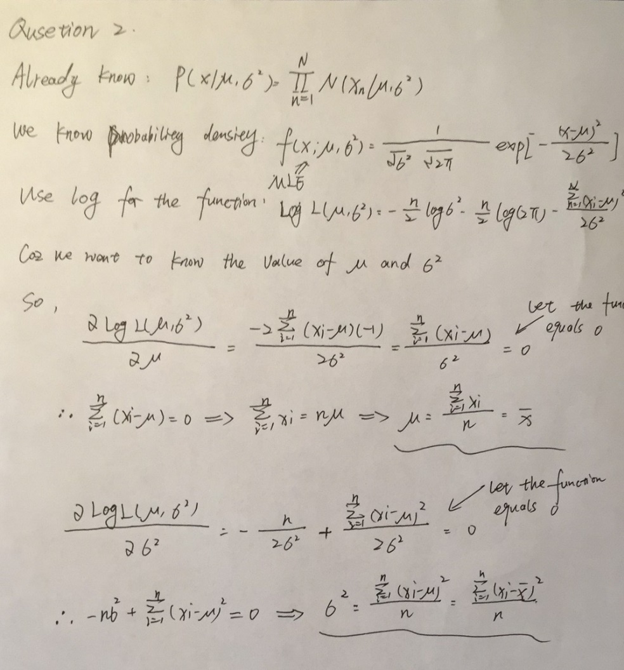

Q3

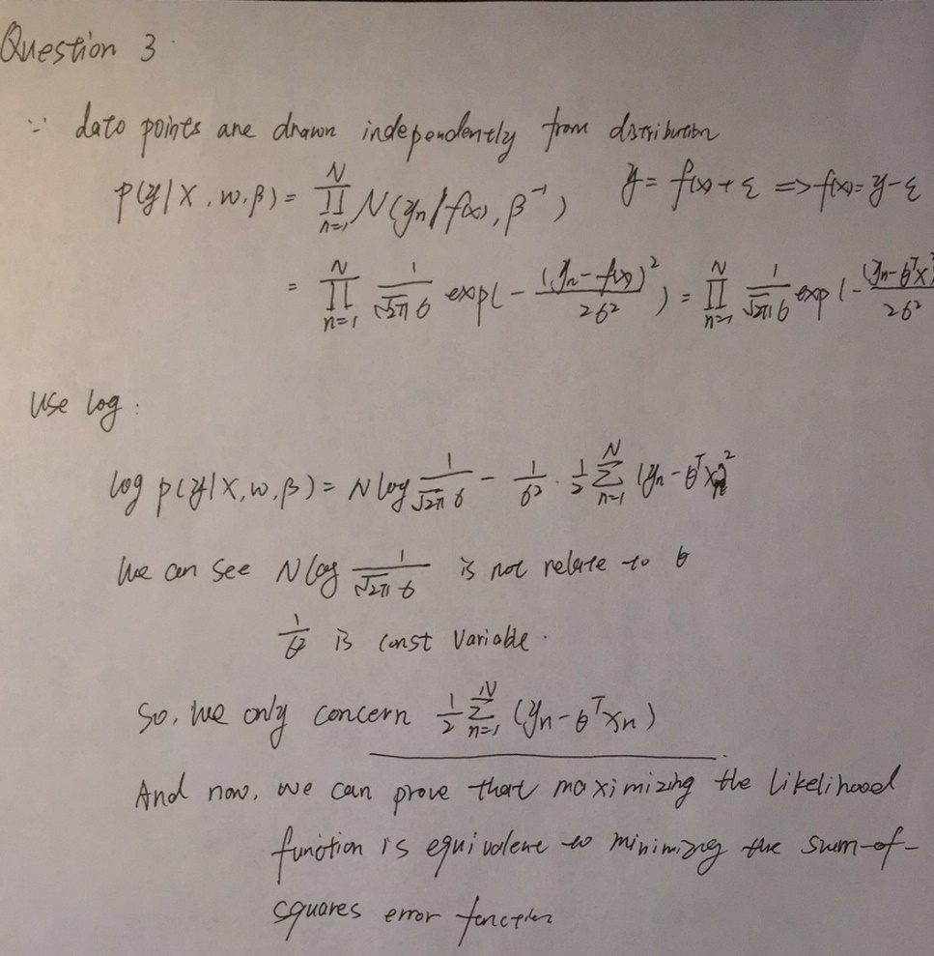

Q4

